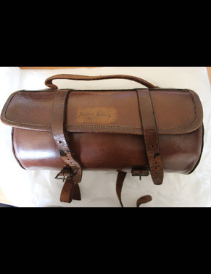 | Object no.: SATAM 2003-0022  Object name: bag for bowls  Creator: Lumley's Ltd.  Title:  Dating: to  Location:  Description: A soft leather bag designed to hold a wooden bowling bowl. The name "David Craig" is inscribed on the front. David Craig was the likely owner of this bag.

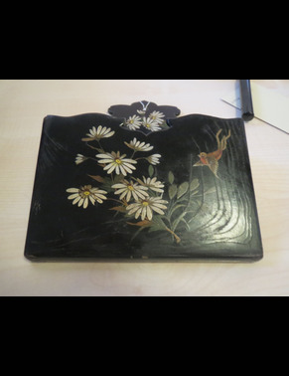 | Object no.: SATAM 2003-0025  Object name: letter rack  Creator:  Title:  Dating: to  Location:  Description: black lacquered letter rack with white flowers and bird

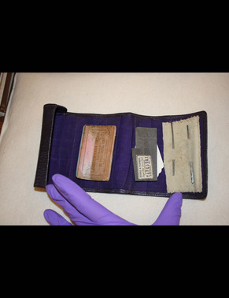 | Object no.: SATAM 2003-0028  Object name: sewing case  Creator:  Title:  Dating: to  Location:  Description: dark purple case, interior bright purple felt. Tubular roll, leather sewing case containing needles and pins, circa 1930s.

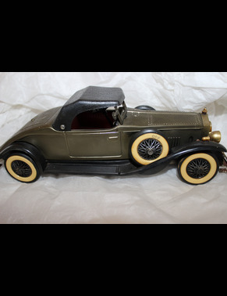 | Object no.: SATAM 2003-0032  Object name: radio  Creator:  Title:  Dating: to  Location:  Description: miniature model; road vehicle, car by "Rolls Royce". Radio, wheels on either side are on/off and tuner knobs. dark green in colour, number plate says 1931. Speaker on bottom.

Object no.: Main-762
Object name: gas light
Creator:
Title:
Dating: to
Location:
Description: large size white ceramic multi-burner gas light on long rigid pipe; for use in large room such as public hall

Object no.: Main-911
Object name: bellows
Creator:
Title:
Dating: to
Location:
Description: domestic fireside bellows, incomplete

Object no.: Main-933
Object name: smoothing iron
Creator:
Title:
Dating: to
Location:
Description: cast iron, flat iron

Object no.: Main-934
Object name: smoothing iron
Creator: Morphy Richards
Title:
Dating: to
Location:
Description: domestic electric iron, 1960's

Object no.: Main-935
Object name: toaster
Creator: Morphy Richards
Title:
Dating: to
Location:
Description: domestic electric toaster, 1960's

Object no.: Main-936
Object name: food mincer
Creator:
Title:
Dating: to
Location:
Description: table top model; in own packaging box

Object no.: Main-937
Object name: baking tray
Creator:
Title:
Dating: to
Location:
Description: sheet metal

Object no.: Main-938
Object name: baking tray
Creator:
Title:
Dating: to
Location:
Description: sheet metal

Object no.: Main-939
Object name: baking tray
Creator:
Title:
Dating: to
Location:
Description: sheet metal

Object no.: Main-940
Object name: baking tray
Creator:
Title:
Dating: to
Location:
Description: sheet metal

Object no.: Main-941
Object name: gas light
Creator:
Title:
Dating: to
Location:
Description: one of a pair of wall-mounted bracket gas lights

Object no.: Main-942
Object name: gas light
Creator:
Title:
Dating: to
Location:
Description: one of a pair of wall-mounted bracket gas lights

Object no.: Main-943
Object name: electric light
Creator:
Title:
Dating: to
Location:
Description: electric lamp, hand held portable, heavy weight for industrial use

Object no.: Main-944
Object name: lamp
Creator:
Title:
Dating: to
Location:
Description: oil fuelled hand lamp; cast iron, small conical body with single wick; inscribed "Wells Engineers Lamp"

Object no.: Main-945
Object name: weighing scales
Creator:
Title:
Dating: to
Location:
Description: small size beam scale, table model kitchen scale; decorative

Object no.: Main-946
Object name: food cutter
Creator:
Title:
Dating: to
Location:
Description: aluminium hand operated press; a perforated cup with pushed; for ricing cooked food such as potatoes;

Object no.: Main-947
Object name: plane
Creator:
Title:
Dating: to
Location:
Description: woodworking plane, type not specified

Object no.: Main-948
Object name: rounders bat
Creator:
Title:
Dating: to
Location:
Description: turned hardwood bat, for game of rounders

Object no.: Main-949
Object name: car lamp
Creator:
Title:
Dating: to
Location:
Description: small size electrically powered car lamp, detachable type (make of vehicle not identified)

Object no.: Main-950
Object name: cash box
Creator:
Title:
Dating: to
Location:
Description: sheet metal; business use

Object no.: Main-951
Object name: food label
Creator:
Title:
Dating: to
Location:
Description: thin rigid white plastic label with metal pin fixing; inscribed "Robertson's Home Fed Ayrshire Bacon. 1st Prize Medal London 1930-31"

Object no.: Main-952
Object name: hoe head
Creator:
Title:
Dating: to
Location:
Description: hand tool, head only of Dutch hoe

Object no.: Main-953
Object name: net sample
Creator: Knox, J. & W., Kilbirnie
Title:
Dating: to
Location:
Description: sample netting for fishing net; manufacturer's product sample, unused

Object no.: Main-954
Object name: yarn, bobbin of
Creator: Knox, J. & W., Kilbirnie
Title:
Dating: to
Location:
Description:

Object no.: Main-955
Object name: yarn, bobbin of
Creator: Knox, J. & W., Kilbirnie
Title:
Dating: to
Location:
Description:

Object no.: Main-956
Object name: yarn, bobbin of
Creator: Knox, J. & W., Kilbirnie
Title:
Dating: to
Location:
Description:

Object no.: Main-957
Object name: yarn, bobbin of
Creator: Knox, J. & W., Kilbirnie
Title:
Dating: to
Location:
Description:

Object no.: Main-958
Object name: yarn, bobbin of
Creator: Knox, J. & W., Kilbirnie
Title:
Dating: to
Location:
Description:

Object no.: Main-959
Object name: yarn, bobbin of
Creator: Knox, J. & W., Kilbirnie
Title:
Dating: to
Location:
Description:

Object no.: Main-960
Object name: yarn, bobbin of
Creator: Knox, J. & W., Kilbirnie
Title:
Dating: to
Location:
Description:

Object no.: Main-961
Object name: yarn, bobbin of
Creator: Knox, J. & W., Kilbirnie
Title:
Dating: to
Location:
Description:

Object no.: Main-962
Object name: yarn, bobbin of
Creator: Knox, J. & W., Kilbirnie
Title:
Dating: to
Location:
Description:

Object no.: Main-963
Object name: yarn, bobbin of
Creator: Knox, J. & W., Kilbirnie
Title:
Dating: to
Location:
Description:

Object no.: Main-964
Object name: yarn, bobbin of
Creator: Knox, J. & W., Kilbirnie
Title:
Dating: to
Location:
Description:

Object no.: Main-965
Object name: yarn, bobbin of
Creator: Knox, J. & W., Kilbirnie
Title:
Dating: to
Location:
Description:

Object no.: Main-966
Object name: yarn, bobbin of
Creator: Knox, J. & W., Kilbirnie
Title:
Dating: to
Location:
Description:

Object no.: Main-967
Object name: yarn, bobbin of
Creator: Knox, J. & W., Kilbirnie
Title:
Dating: to
Location:
Description:

Object no.: Main-968
Object name: yarn, bobbin of
Creator: Knox, J. & W., Kilbirnie
Title:
Dating: to
Location:
Description:

Object no.: Main-969
Object name: yarn, bobbin of
Creator: Knox, J. & W., Kilbirnie
Title:
Dating: to
Location:
Description:

Object no.: Main-970
Object name: yarn, bobbin of
Creator: Knox, J. & W., Kilbirnie
Title:
Dating: to
Location:
Description:

Object no.: Main-971
Object name: food label
Creator:
Title:
Dating: to
Location:
Description: thin rigid white plastic label with metal pin fixing; inscribed "Laird's Home Cured Bacon"

Object no.: Main-972
Object name: bottle
Creator:
Title:
Dating: to
Location:
Description: clear glass; to contain lemonade by Struthers, Lochwinnoch

Object no.: Main-973
Object name: jar
Creator:
Title:
Dating: to
Location:
Description: brown glass, shape specific to brand; to contain concentrated beef stock, brand "Bovril"

Object no.: Main-974
Object name: jar
Creator:
Title:
Dating: to
Location:
Description: brown glass, shape specific to brand; to contain concentrated beef stock, brand "Bovril"

Object no.: Main-975
Object name: jar
Creator:
Title:
Dating: to
Location:
Description: brown glass, shape specific to brand; to contain concentrated beef stock, brand "Bovril"

Object no.: Main-976
Object name: bottle, siphon
Creator:
Title:
Dating: to
Location:
Description: clear heavy glass with shaped nozzle cap; to contain soda water, by Struthers, Lochwinnoch

Object no.: Main-977
Object name: bottle, siphon
Creator:
Title:
Dating: to
Location:
Description: clear heavy glass with shaped nozzle cap; to contain soda water by Baillie Clark & Co.

Object no.: Main-978
Object name: tokens, trade
Creator:
Title:
Dating: to
Location:
Description: large quantity (not quantified) round plastic tokens, various types (milk tokens, etc.); stored in various small containers

Object no.: Main-979
Object name: printing equipment
Creator:
Title:
Dating: to
Location:
Description: quantity loose small wooden printing blocks, numerals and cash symbols; used for printing shop price labels

Object no.: Main-1001
Object name: washboard
Creator:
Title:
Dating: to
Location:
Description:

Object no.: Main-1002
Object name: hot water bottle
Creator:
Title:
Dating: to
Location:
Description: sheet metal bottle, green enamelled

