Continuity and Change in Scottish Death and Burial Customs, 1875–2025
By
Joseph McTaggart
December 2025

Contents

1 Introduction 1
2 Literature Review 1
3 Methodology 3
3.1 Data Sources 3
3.2 Secondary Literature 3
3.3 Analytical Approach 4
3.4 Scope and Limitations 4
4 Traditional Customs and Beliefs (1875 to 1930) 4
4.1 The Home as the Centre of Death 4
4.2 Community Roles and Funeral Processions 4
4.3 Gravestones, Lairs, and Material Culture 5
4.4 Commemoration and National Ritual 6
5 Transition and Transformation (1930 to 1990) 6
5.1 Transport and the Role of Undertakers 6
5.2 Changing Gender Roles and Social Gathering in Funeral Practice 6
5.3 Professionalisation of Care for the Body 7
5.4 Cremation, Media and Sacred Obligation of other Faiths 7
6 Contemporary Customs (1990 to 2025) 8
6.1 Patterns Around Dying 8
6.2 Digital Communication and Memorials 8
6.3 Headstones, Inscriptions, and Material Change 8
6.4 Religious and Ritual Diversity 9
6.5 Sacred Obligation in Contemporary Practice 9
6.6 Contemporary Challenges 9
7 Continuity, Change, and Interpretation 9
7.1 Continuity of Sacred Obligation 9
7.2 Religious Diversity and Changing Expectations 10
7.3 Older Customs in Modern Spaces 10
7.4 Scots Continue to Respond to the call of Sacred Obligation 10
Bibliography 11
Appendices 16
Appendix A - Summary Table of Continuity and Change in Scottish Death Customs (1875–2025) 16
Appendix B - Historical Photographs, Headstones and Family Burial Records 17
Appendix C – Contemporary Issues and Digital Memorial Practices 21

Introduction

This project investigates how death and burial customs in Scotland have evolved from Eighteen Seventy-Five to the present day by tracing their transformation across three broad periods, traditional (Eighteen Seventy-Five to Nineteen Thirty), transitional (Nineteen Thirty to Nineteen Ninety), and contemporary (Nineteen Ninety to Twenty Twenty-Five), demonstrating continual adaptation of the acts of sacred obligation. Sacred obligation in this essay is defined as the enduring moral and communal duty to care for the dead with dignity, to mark their passing through ritual and to maintain their remembrance as a social and spiritual expression.
Drawing on public domain texts supported by secondary academic sources, the essay explores changes in where people die, how death is communicated and commemorated, and how the acts of sacred obligation have endured. Personal recollections are also used as supplementary evidence in line with the project guidelines.
In addition to tracing these developments, the essay considers how ideas of dignity and communal responsibility show up across different generations. These shifts reveal how Scottish communities understand respect for the dead, as well as looking at how technological, demographic, and economic factors have reshaped the social setting of death without replacing the psychological functions of closure that funerals offer. By approaching the material chronologically, the project highlights certain enduring customs and how their meaning is passed down between generations to the present.

Literature Review

Academic and historical scholarship on Scottish death customs and everyday life provides a framework for interpreting the primary data used in this project. A central theme is the continuity of sacred obligation and how that manifests in different generations.

Tarlow’s Bereavement and Commemoration: An Archaeology of Mortality (1999) holds the idea that commemoration is not simply an individual expression of grief but a statement about relationships and how the deceased is viewed from a communal perspective. Her emphasis on relational and communicative aspects of mourning helps to frame Scottish funeral customs as evidence of community, kinship, and obligation rather than a private response to loss.
Abrams and Brown’s A History of Everyday Life in Twentieth-Century Scotland (2010) highlights how the growth of the welfare state and hospitals shifted death from domestic to professional settings. This supports the mid-twentieth-century transition from home deaths and neighbourly care to hospital deaths and undertaker-led funerals.
Macgregor’s Getting Married in Scotland (2000) provides insight into how Scottish rites of passage hold communal ties together. Rituals such as weddings and funerals are important practices that adapt to new contexts without losing their core meaning.
Historical sources supply evidence for earlier belief systems. Campbell’s Popular Tales of the West Highlands (1860 to 1862) records death omens and second sight, illustrating the mental world of Gaelic communities, giving us a backdrop to life up to 1875. Stewart’s A Highland Parish (1885) describes the parish as a “commonwealth of mutual obligation.” Willsher’s Understanding Scottish Graveyards (1985) supports the theory that unmarked lairs, particularly in stricter religious traditions, were not always due to economic hardship.
These works suggest that funerary customs demonstrate kinship and that moving death from the home into institutions changes community involvement but does not eradicate it, and that gravestones and other objects involved in the acts of sacred obligation reveal changing beliefs, not vanishing beliefs.

Methodology

This project combines a review of secondary literature with the collection and analysis of primary data from publicly available sources. All material was organised chronologically and interpreted within a wider historical and cultural context.

Data Sources

The primary data consists of public domain texts and records, including older descriptions of funeral customs, government reports and newspaper material as well as historical photographs from the author’s personal archive and contemporary screenshots of online memorials and announcements (see Appendices B and C). Personal recollections are used only as supplementary evidence and are clearly identified in accordance with the project guidelines. RootsWeb is used only to illustrate surviving folk memory and is not treated as authoritative historical evidence.
Primary audio material was also consulted from the Tobar an Dualchais / Kist o’ Riches archive. These items include mid-twentieth-century testimony relating to changing funeral practices (SA1969.025) as well as recorded recollections of memorial rhymes (SA1953.236.B5). Full archival details, including original source numbers, are listed in the bibliography.

Secondary Literature

Tarlow (1999), Abrams and Brown (2010), and Macgregor (2000) were used to contextualise the primary data, particularly regarding themes of community, kinship, ritual, and the transition from domestic to institutional settings of death. Additional historical and cultural studies, including Stewart (1885), Campbell (1860 to 1862), and Willsher (1985), gave the interpretation of earlier beliefs, kinship structures, and cemetery traditions.

Analytical Approach

A comparative method was used to identify continuity and change across the three periods and developments were interpreted in relation to wider historical factors such as secularisation, migration, technological change, and the growing professionalisation of funerary practices.

Scope and Limitations

As the project relies on public domain data and personal recollection, the evidence is sufficient for identifying major patterns in how Scottish death customs reflect social values and communal cohesion, though it is not comprehensive. Personal recollections contribute atmosphere and give emotional context while archival and public sources provide authenticity. Grounding the analysis in publicly accessible primary data ensures that the project aligns with the module’s emphasis on public-domain research.

Traditional Customs and Beliefs (1875 to 1930)

The Home as the Centre of Death

In late nineteenth-century Scotland, death was both a domestic and communal responsibility (Scots Language Centre, 2015). The home was the central site of death; people often died surrounded by family, and the body was laid out in the best room of the house, which temporarily became a place of shared memory and even sanctity (Scots Language Centre, 2015). Mirrors were covered, clocks stopped, and neighbours visited to pay their respects (RootsWeb, no date).

Community Roles and Funeral Processions

Women from the community traditionally prepared the body for the wake, washing and dressing it in the house (Scots Language Centre, 2015). Funerals carried a strong communal sense of duty. In Barra, regional accounts suggest that many believed “everyone who could walk” would attend (Vallee, 1995; RootsWeb, n.d.). Coffins were sometimes transported by horse and cart or carried on shoulders by neighbours, and processions commonly included psalm singing or quiet accompaniment (Graveyards of Scotland, n.d. Scots Language Centre, 2015). A photograph from nineteen hundred and five records such a procession (Appendix B, Fig. 1; McTaggart, 2025).

Gravestones, Lairs, and Material Culture

Material culture reflected these values, which is why gravestones were often elaborate, bearing moral messages or biblical verses (Willsher,1985). Imagery such as clasped hands and urns expressed belief and remembrance. Examples of Victorian style headstones can be found in Appendix B (Fig. 2 and 3, McTaggart, 2025). Unmarked graves could reflect religious belief or practical necessity in getting the place correct and in stricter Presbyterian communities, families sometimes avoided headstones because carved images were viewed as encouraging pride or idolatry (RootsWeb, n.d. Scots Language Centre, 2015). Economic necessity also played a major role as many families simply could not afford a gravestone yet still purchased adjoining lairs so relatives could be buried side by side. When unmarked, such family lairs can appear as open grass to outsiders, though their boundaries and occupants were known to the community. The author’s great-great-grandparents’ two lairs are one such example of the above (Appendix B, Fig. 4, McTaggart, 2025), covering six members of the family interred over five decades.
Additional evidence of nineteenth and early twentieth-century gravestones can be found in oral recordings of inscriptions. A mid-century Tobar an Dualchais recording preserves the well known verse, “Remember me as you pass by…” (Tobar an Dualchais, SA1953.236.B5). Although recorded in Nineteen Fifty-Three, the inscription reflects a much older tradition of poems and rhymes on gravestones across Scotland, where short verses reminded the living of mortality, sacred obligation, and the need to prepare for death.

Commemoration and National Ritual

After 1919, King George V’s introduction of the two-minute silence reshaped national remembrance (Open University, n.d.) resulting in commemoration being collective, and grief publicly shared for the war dead. A practice which is still commemorated today.

Transition and Transformation (1930 to 1990)

By the early twentieth century, Scottish death practices began to shift as urbanisation, migration, and hospital expansion gradually moved care from home to institutional settings. The Eighty-Second Annual Report of the Registrar-General for Scotland shows that by the early Nineteen Thirties, an increasing proportion of deaths were occurring under medical supervision (Registrar General for Scotland, 1932). Reports from the Nineteen Thirties to the Nineteen Eighties show that institutional deaths steadily overtook home deaths (Registrar General for Scotland, 1989).

Transport and the Role of Undertakers

A family memory records a coffin being transported from Glasgow to Northern Ireland on a bus luggage rack in Nineteen Fifty-Nine (J. McTaggart, Nineteen Fifty-Nine), a practice still recorded until the Nineteen Seventies (BBC Alba, 2018). These informal arrangements disappeared as undertakers assumed responsibility for transporting the deceased, reflecting growing professionalisation in the industry of death.
An audio testimony from Islay also notes that horses and carts, as noted earlier in Section 4.2, had stopped being used in Islay, a marked difference to the previous generation (Tobar an Dualchais, SA1969.025).

Changing Gender Roles and Social Gathering in Funeral Practice

Another recollection from Nineteen Eighty describes six cords tied to the coffin for lowering into a family member’s grave, an office traditionally held by males. On this occasion, the deceased’s sister took one of the cords, breaking with custom (personal recollection, J. McTaggart, Nineteen Eighty). Earlier Highland accounts confirm that coffin-carrying and grave-lowering were traditionally performed by male relatives (Campbell, 1900). Social behaviour also evolved, with post-funeral gatherings now taking place in modern establishments, the author recalls this one took place in a milk bar.

Professionalisation of Care for the Body

A further recollection notes that after a Grandmother’s death in Nineteen Eighty-One, a professional undertaker prepared the body over three days, a role once performed by neighbours or kin. The undertaker also conducted a short religious service at the graveside, showing the diminishing participation of family labour and professional clergy (personal recollection, J. McTaggart, Nineteen Eighty-One).

Cremation, Media and Sacred Obligation of other Faiths

Cremation grew in popularity during this period, supported both by the wider availability of crematoria and by changing forms of public communication as radio and television became established. It is reported by the Cremation Society that in nineteen eighty-nine, fifty-five percent of all Scottish funerals were by cremation (The Cremation Society of Great Britain, 2025). Coverage also evolved, with more detailed obituaries appearing in local publications such as the Kilmarnock Standard (Kilmarnock Standard, n.d.), and some deaths being reported through emerging broadcast media. Glasgow’s cemeteries such as Cardonald, changed over time as the city’s population, expectations, and cultural needs developed. Older layouts were adapted to improve access, new sections were added for expanding communities, and spaces were reorganised to reflect a more diverse range of customs and beliefs. Traditional rituals such as the Islamic washing of the body invoked memories of long-standing patterns of neighbourly care, even as the wider burial environment became more structured and regulated. Acts of sacred obligation also grew in prominence with annual ceremonies at war memorials becoming a regular way for communities to express a shared sense of identity.

Contemporary Customs (1990 to 2025)

Patterns Around Dying

In contemporary Scotland, patterns around dying show both continuity and change. Hospitals and hospices remain frequent places of death, yet many people express a preference to spend their final days at home with support from palliative care services.

Digital Communication and Memorials

Communication about death has shifted online. Families post memorials and notices in digital newspapers (Appendix C, Fig. 1; Ardrossan & Saltcoats Herald, 2024), and online tribute pages now allow relatives to share condolences or make charitable donations in the name of the deceased. Muslim community posts often include Qur’anic verses (Appendix C, Fig. 2; Facebook, 2025). Livestreaming of funerals, especially during public health restrictions, continues to enable broad participation.

Headstones, Inscriptions, and Material Change

Headstone inscriptions have shifted from biblical verses to personal statements such as “Beloved Husband” or “Forever in Our Hearts”, and designs now range from secular to more personalised (Appendix C, Fig. 3; McTaggart, Twenty Twenty-Five).
Material practices have also changed. Councils now conduct large-scale headstone safety inspections, sometimes marking or laying flat stones deemed unstable (Appendix C, Fig. 4 and 5; McTaggart, Twenty Twenty-Five). North Ayrshire Council has faced repeated criticism in local media for its handling of headstone safety policies, including reports of families being charged significant sums to reinstate stones deemed unsafe (Ardrossan and Saltcoats Herald, 2016). Some families opt for plaques instead (Appendix C, Fig. 5 and 6; McTaggart, Twenty Twenty-Five).

Religious and Ritual Diversity

Religious diversity has broadened Scottish funerary practice, with Humanist storytelling ceremonies, multi-faith provision, and interfaith funerals now a common part of contemporary public living.

Sacred Obligation in Contemporary Practice

Sacred obligation continues to shape how families honour the dead, where photographs, music, and mementoes echo older traditions of song and lament, digital platforms broaden communal mourning beyond geographical limits.

Contemporary Challenges

Modern funeral processions also suffer from traffic problems, a recent hearse road-rage incident reported by BBC News prompted renewed calls for respect (BBC News, 2025).

Continuity, Change, and Interpretation

Continuity of Sacred Obligation
Across the three periods, the function of sacred obligation remains and evolves, Appendix A illustrates the major shifts from home-based funerals to professional ones, from churchyards to crematoria, and from oral to digital communication with developments shaped by industrialisation, urbanisation, secularisation, and globalisation. Commercialisation made death more private but digital platforms have reintroduced public mourning on a global scale, reflecting earlier communal values. The flattening of unstable headstones also highlights debates about heritage, safety, and responsibility for lair upkeep, while demonstrating how memoria is changing. Although many families choose plaques or online memorials, the underlying impulse to preserve memory and maintain sacred obligation remains the same.

Religious Diversity and Changing Expectations
Increasing religious diversity has broadened Scottish funerary practice without replacing traditional forms. Islamic washing rites of the deceased restore elements of family care of the body. Pagan rituals, Humanist celebrations, and Christian or interfaith services share similar language of closure and respect. Contemporary concerns such as appeals for patience around funeral processions or the rise of secular funerals indicate changing expectations rather than any loss of meaning.

Older Customs in Modern Spaces
Comparing the three periods reveals that older customs do not disappear, they are reinterpreted to suit modern circumstances and that the decline of shoulder carrying coffins, home wakes, or neighbour-led preparation does not signal the disappearance of community care or mourning, these reappear in online tributes, charitable donations, livestreams, and memorial gatherings. The rise of cremation reflects spatial and economic factors and not a break with earlier values and forms of sacred obligation adapt but remain sound at heart.

Scots Continue to Respond to the call of Sacred Obligation
From keening in the past to newspaper obituaries or Facebook posts, Scots continue to respond to death with dignity, and care. Industrialisation reshaped where people die, secularisation and immigration diversified ritual, and technology has transformed commemorative spaces, but the need to mark loss remains constant within the practice of sacred obligation. Supporting materials and visual examples appear in Appendices A, B, and C.

Bibliography

Secondary Academic Sources
Abrams, L. and Brown, C.G. (eds) (2010) A History of Everyday Life in Twentieth-Century Scotland. Edinburgh: Edinburgh University Press.
Macgregor, I. (2000) Getting Married in Scotland. Edinburgh: National Museums of Scotland.
Tarlow, S. (1999) Bereavement and Commemoration: An Archaeology of Mortality. Oxford: Blackwell.
Public Domain Online and Government Sources
Ardrossan and Saltcoats Herald (2016) ‘Former builder hits out at North Ayrshire Council after £20,000 paid to fix headstones’. Available at: https://www.ardrossanherald.com/news/14299174.a-former-builder-has-hit-out-at-north-ayrshire-council-after-they-revealed-residents-have-paid-over-20000-in-the-past-year-to-fix-headstones/ (Accessed: 11 November 2025).
Ardrossan and Saltcoats Herald (2024) Online obituary and memorial announcements.
Available at: https://www.ardrossanherald.com (Accessed: 11 November 2025).
BBC Alba (2018) Bus Ghlaschu / Glasgow Bus, Series 1, Episode 3. Broadcast 3 August. BBC Alba.
BBC News (2025) Plea to respect funeral processions after road-rage crash. Available at: https://www.bbc.com/news/articles/c4gp04kqzdeo (Accessed: 20 November).
Campbell, J.F. (1860–1862) Popular Tales of the West Highlands. Edinburgh: Edmonston &
Douglas. Public domain.
Campbell, J.G. (1900) Superstitions of the Highlands and Islands of Scotland. Glasgow: James Maclehose & Sons. Public domain.
The Cremation Society of Great Britain. 2025. Progress of cremation in the British Islands 1885 2024. Available at: https://www.cremation.org.uk/progress-of-cremation-united-kingdom (Accessed: 21 November 2025).
Graveyards of Scotland (n.d.) Gravestone symbolism and cemetery heritage.
Available at: https://graveyardsofscotland.com (Accessed: various dates in 2025).
Home Office (1933) Report of the Departmental Committee on Death Certification and Coroners. London: His Majesty’s Stationery Office. Public domain.
Kilmarnock Standard (n.d.) Obituaries. British Newspaper Archive. Available at: https://www.britishnewspaperarchive.co.uk (Accessed: 20 November 2025).
Open University (n.d.) Why do we have two minutes’ silence on 11th November?
Available at: https://www.open.edu/openlearn/history-the-arts/history/why-do-we-have-two-minutes-silence-on-11th-november
(Accessed: 11 November 2025).
Registrar General for Scotland (1932) Eighty-Second Annual Report of the Registrar-General for Scotland. Edinburgh: His Majesty’s Stationery Office. (Public domain).
Available at: https://www.nrscotland.gov.uk/statistics-and-data (Accessed: 20 November 2025).
Registrar General for Scotland (1930–1989) Annual Reports of the Registrar-General for Scotland. Edinburgh: His Majesty’s Stationery Office. Public domain.
RootsWeb (n.d.) ‘Scotland Burial & Funeral Customs (19th century)’.
Available at: https://freepages.rootsweb.com/~bldr/folklore/customs2.html (Accessed: 19 November 2025).
Scots Language Centre (2015) The Funeral in Scots.
Available at: https://media.scotslanguage.com/library/document/The%20Funeral%20in%20Scots.pdf (Accessed: 11 November 2025).
Stewart, A. (1885) A Highland Parish. Edinburgh: privately printed. Public domain.
Available at: https://archive.org/details/highlandparish00stewuoft/ (Accessed:27 November 2025).
Tobar an Dualchais (1953) SA1953.236.B5: Inscriptions on a headstone and a gate, and a rhyme from Kelso. Available at: https://www.tobarandualchais.co.uk (Accessed: 27 November 2025).
Tobar an Dualchais (1969) Funerals in Islay. SA1969.025. School of Scottish Studies Archives, University of Edinburgh. Available at: https://www.tobarandualchais.co.uk/ (Accessed: 27 November 2025).
Vallee, F.G. (1955) ‘Burial and Mourning Customs in a Hebridean Community’, Man, 55, pp. 145–147.
Available at: https://ehrafworldcultures.yale.edu/cultures/es10/documents/014 (Accessed: 11 November 2025).
Willsher, B. (1985) Understanding Scottish Graveyards. Edinburgh. Public-domain survey materials available at:
https://www.scottishgraveyards.org.uk (Accessed: 27 November 2025).
Appendices
Appendix A - McTaggart, J. (2025) Summary Table of Continuity and Change in Scottish Death Customs (1875–2025). Included as Appendix A.
Appendix B - McTaggart, J. (2025) Historical Photographs, Headstones and Family Burial Records. Author’s personal collection. Included as Appendix B.
Figure 1. McTaggart, J. (2025) Funeral procession of R.W. Knox, Kilbirnie, c.1905. Photograph from the author’s photographic archive.
Figure 2, McTaggart, J. (2025) Late Victorian Era Headstone in Kilbirnie, North Ayrshire. Photograph from the author’s photographic archive.
Figure 3, McTaggart, J. (2025) Late Victorian Era Headstone in Kilbirnie, North Ayrshire. Photograph from the author’s photographic archive.
Figure 4, McTaggart, J. (2025) Family lairs E630-E631, Kilbirnie Cemetery: unmarked adjoining plots of the author’s great-great-grandparents and descendants. Photograph from the author’s photographic archive.
Appendix C - McTaggart, J. (2025) Contemporary Issues and Digital Memorial Practices
included as Appendix C.

Figure 1, Ardrossan and Saltcoats Herald (2024) Notices. Available at: https://www.ardrossanherald.com/notices/ (Accessed: 11 November 2025)..
Figure 2, Facebook (2025) Public funeral announcement. Available at: https://www.facebook.com/photo/?fbid=10162491703886867&set=gm.32601762696105146&idorvanity=245156278859207 (Accessed: 11 November 2025).
Figure 3, McTaggart, J. (2025) Headstone “Forever in our Hearts” with Guitar.
Photograph from the author’s photographic archive.
Figure 4, McTaggart, J. (2025) Headstone with “Failed Safety Test” sticker, Kilbirnie Cemetery. Photograph from the author’s photographic archive.
Figure 5, McTaggart, J. (2025) Headstone with “Failed Safety Test” sticker, Kilbirnie Cemetery. Photograph from the author’s photographic archive.
Figure 6, McTaggart, J. (2025) Headstone with Plaque, Kilbirnie Cemetery.
Photograph from the author’s photographic archive.
Figure 7, McTaggart, J. (2025) Plaque Kilbirnie Cemetery.
Photograph from the author’s photographic archive.
Personal Recollections
McTaggart, J. (1959) Personal recollection of funeral of John Loughran (Glasgow-Ardrossan-Northern Ireland route).
McTaggart, J. (1980) Personal recollection of cousin Esther McTaggart’s funeral, Kilbirnie, Ayrshire.
McTaggart, J. (1981) Personal recollection of Grandmother’s death, Beith, Ayrshire.

Appendices

Appendix A - Summary Table of Continuity and Change in Scottish Death Customs (1875–2025)

Years | Place of Death | Communication | Ritual Form | Commemoration | Religious Context
1875 | Home | Word of mouth | Wakes, processions, hymns | Gravestones with biblical verses | Mostly Christian
1930  1990 | Home hospital | Newspaper  Obituary | Professional funeral, cremation | sympathy cards, memorials stones,  Remembrance- Gardens | Diversifying with Eastern faiths & pagan
2025 | Hospital hospice, home if - possible. | Social Media  Digital notices | Personalised, Secular services | Online tributes Hybrid rituals Plaques, Overt- memorials,  Charitable Donations | Highly diverse, including- Humanist and interfaith

Appendix B - Historical Photographs, Headstones and Family Burial Records

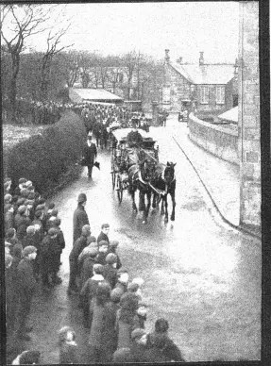
Figure 1, Appendix B.
Funeral procession of R.W. Knox, Kilbirnie, North Ayrshire 1905.
From the author’s photographic archive.

Appendix B (continued)

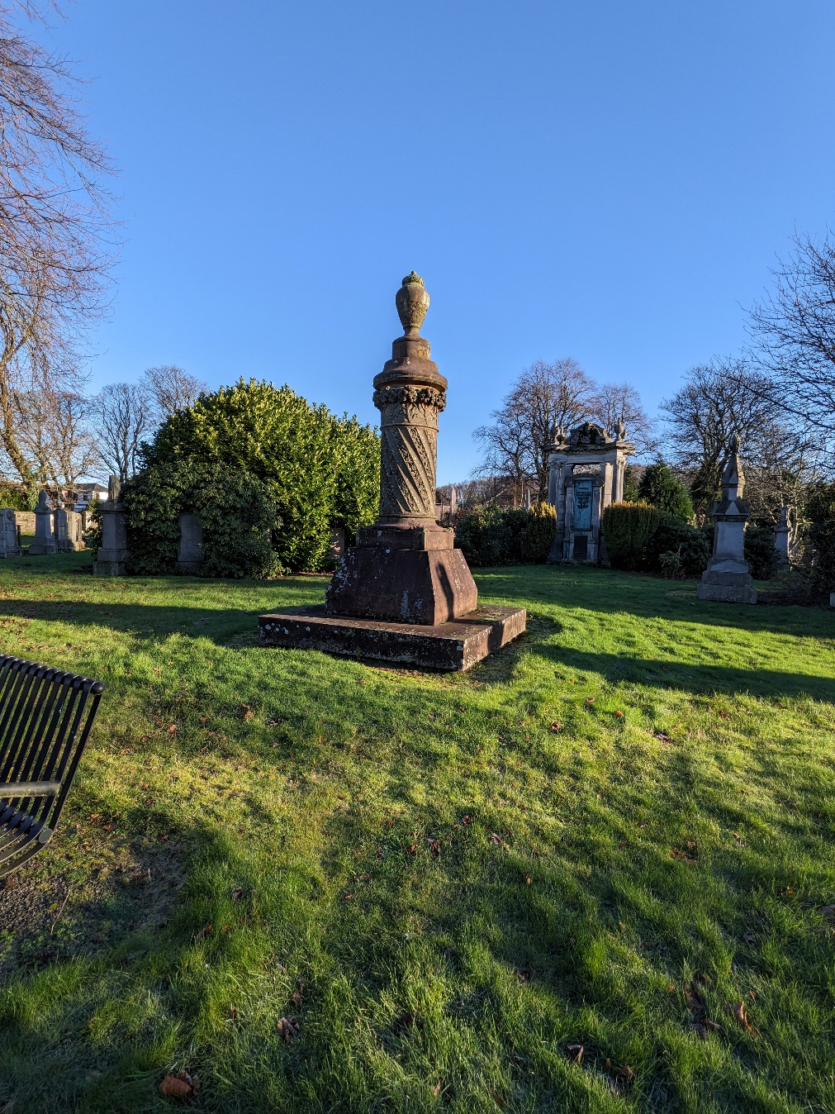
Figure 2. Appendix B.
Late Victorian Era Headstone in Kilbirnie, North Ayrshire.
From the author’s photographic archive.

Appendix B (continued)

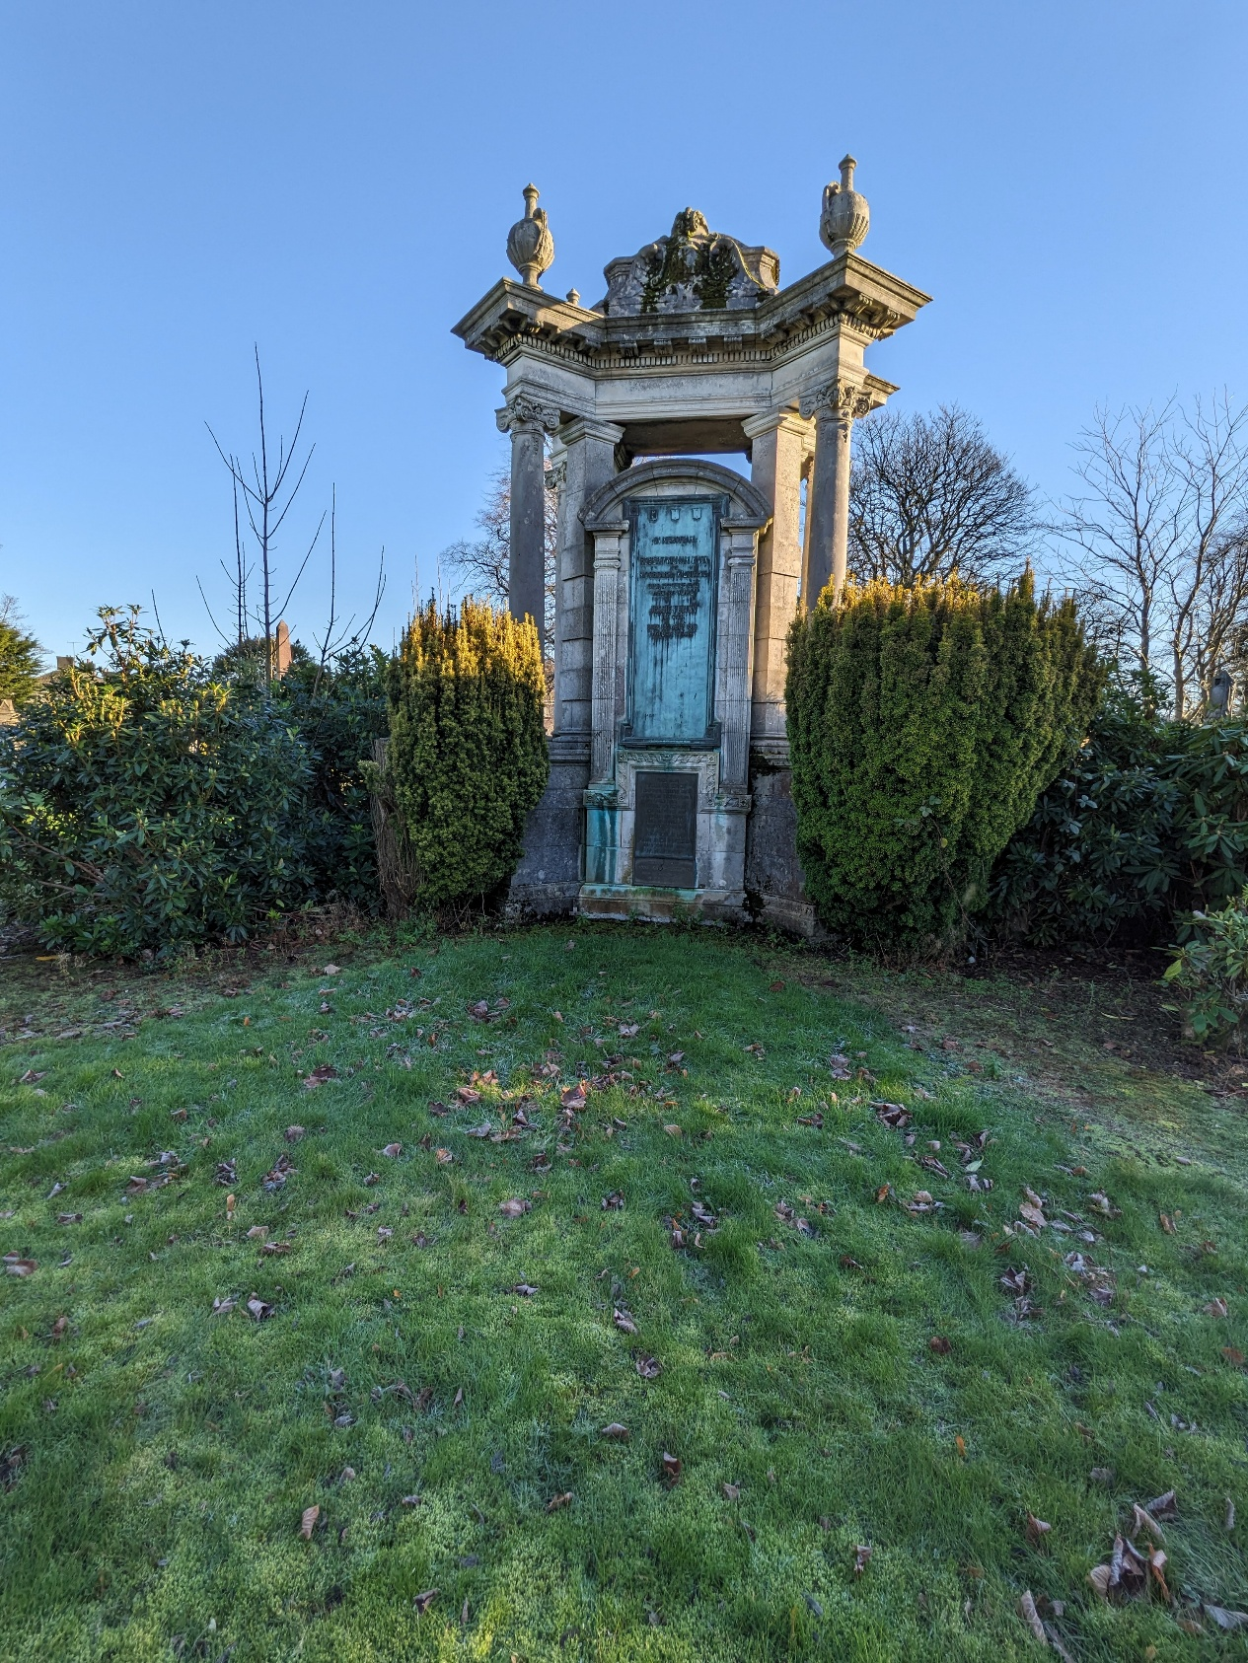
Figure 3. Appendix B.
Late Victorian Era Headstone in Kilbirnie, North Ayrshire.
From the author’s photographic archive.

Appendix B (continued)

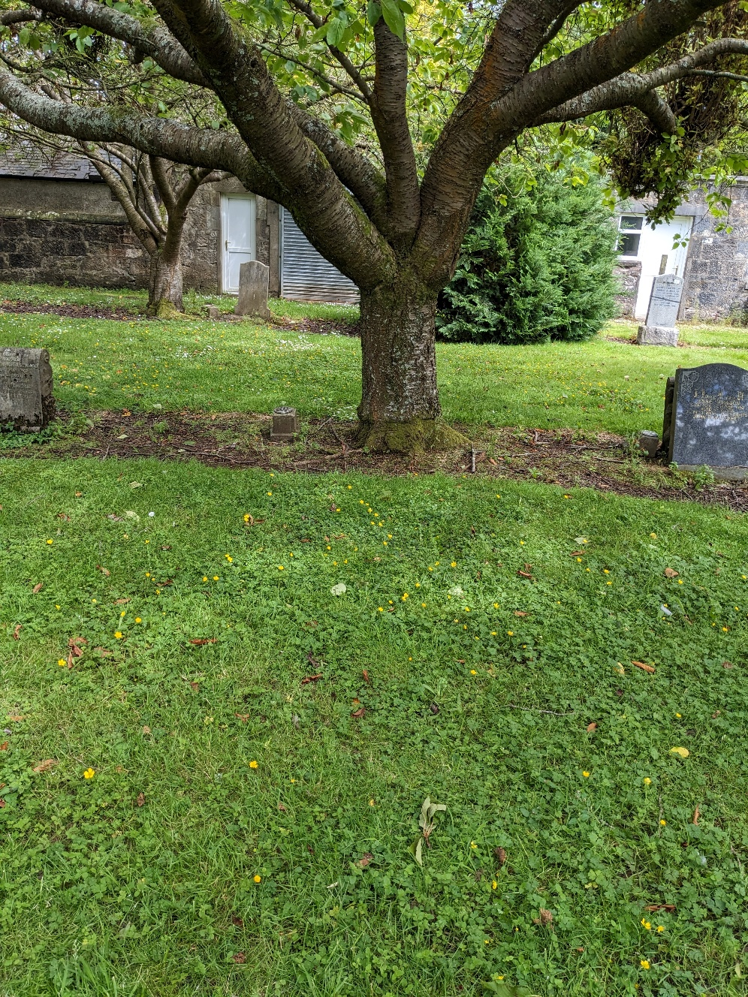
Figure 4. Appendix B
Family lairs E630, E631
the author’s Great-Great-Grandparents and their children, showing the unmarked adjoining plots as photographed by the author (2025)
(image from author’s photographic archive)

Appendix C – Contemporary Issues and Digital Memorial Practices
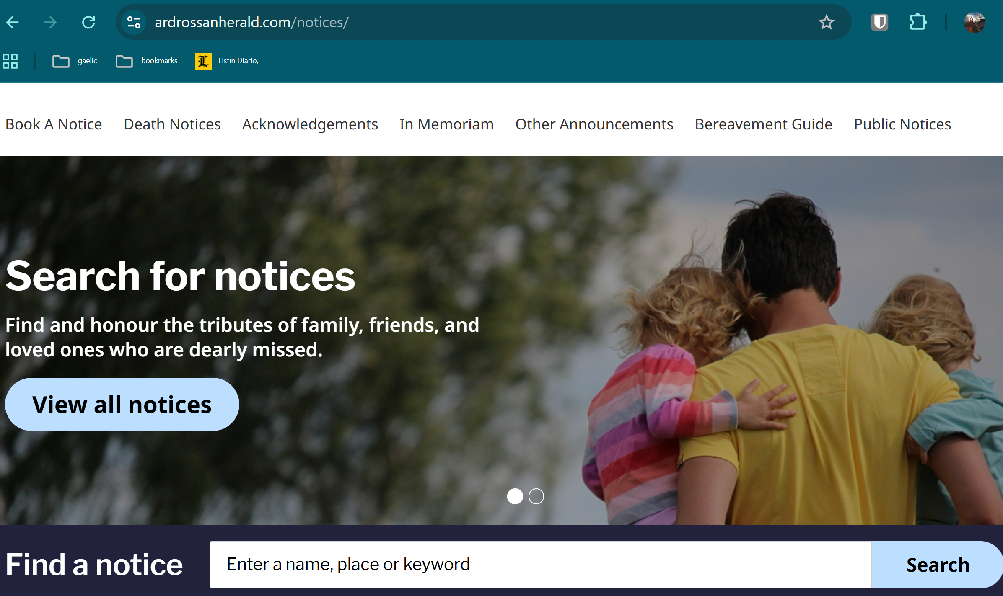
Figure 1. Appendix C.
Online obituary and memorial announcements
(Ardrossan and Saltcoats Herald, 2024; screenshot by author).
Source: https://www.ardrossanherald.com/notices/
(Accessed: 11 November 2025).

Appendix C (continued)
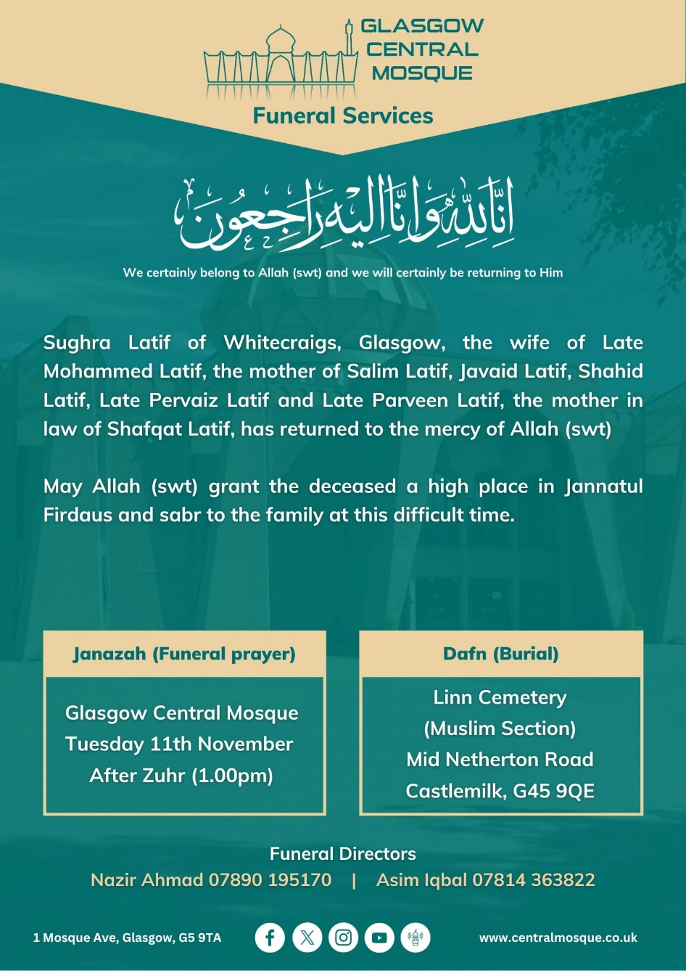
Figure 2. Appendix C.
Public Muslim funeral announcement
containing a Qur’anic verse and janāzah prayer
Information (Facebook post; screenshot by author).
Source: https://www.facebook.com/photo/?fbid=10162491703886867&set=gm.32601762696105146&idorvanity=245156278859207
(Accessed: 11 November 2025).

Appendix C (continued)

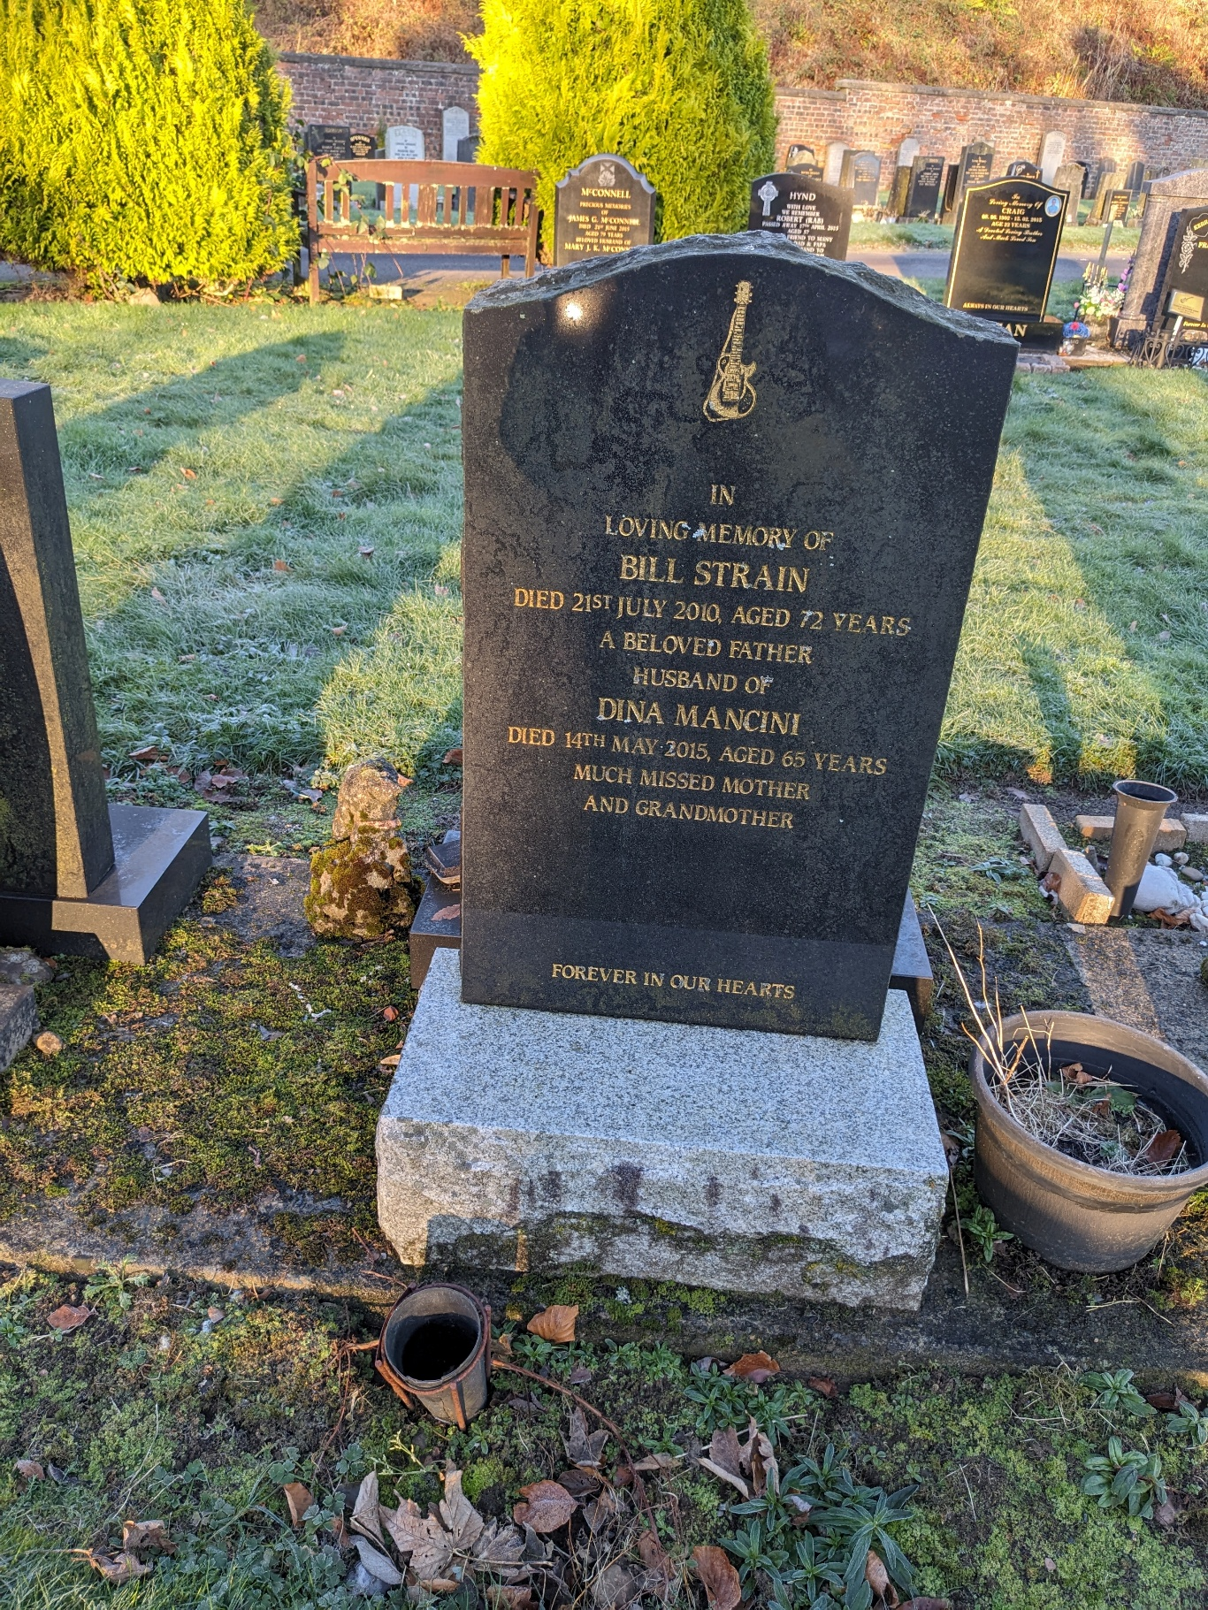
Figure 3. Appendix C.
Headstone “Forever in our Hearts” with Guitar.
From the author’s photographic archive.
Appendix C (Continued)

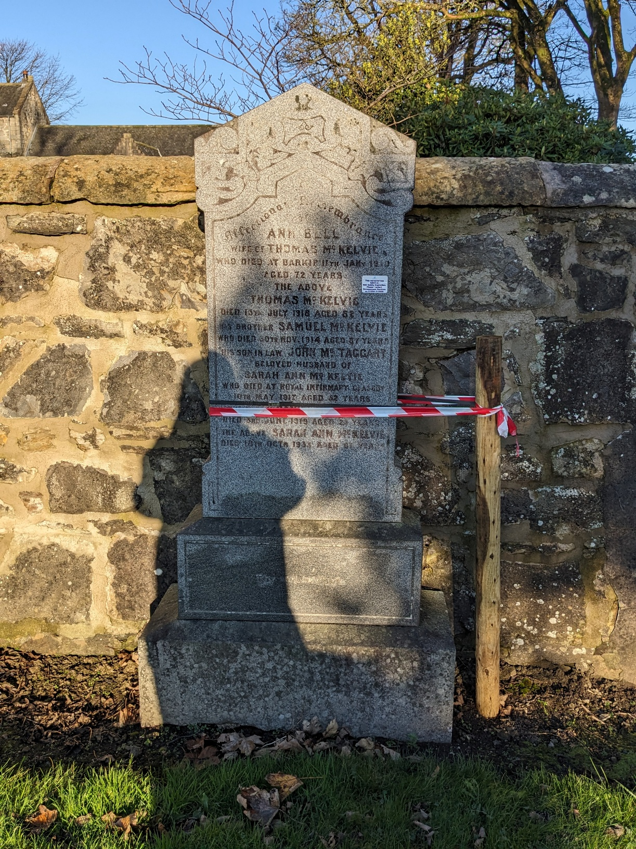

Figure 4. Appendix C.
Headstone with “Failed Safety Test” sticker
From the author’s photographic archive.

Appendix C (Continued)

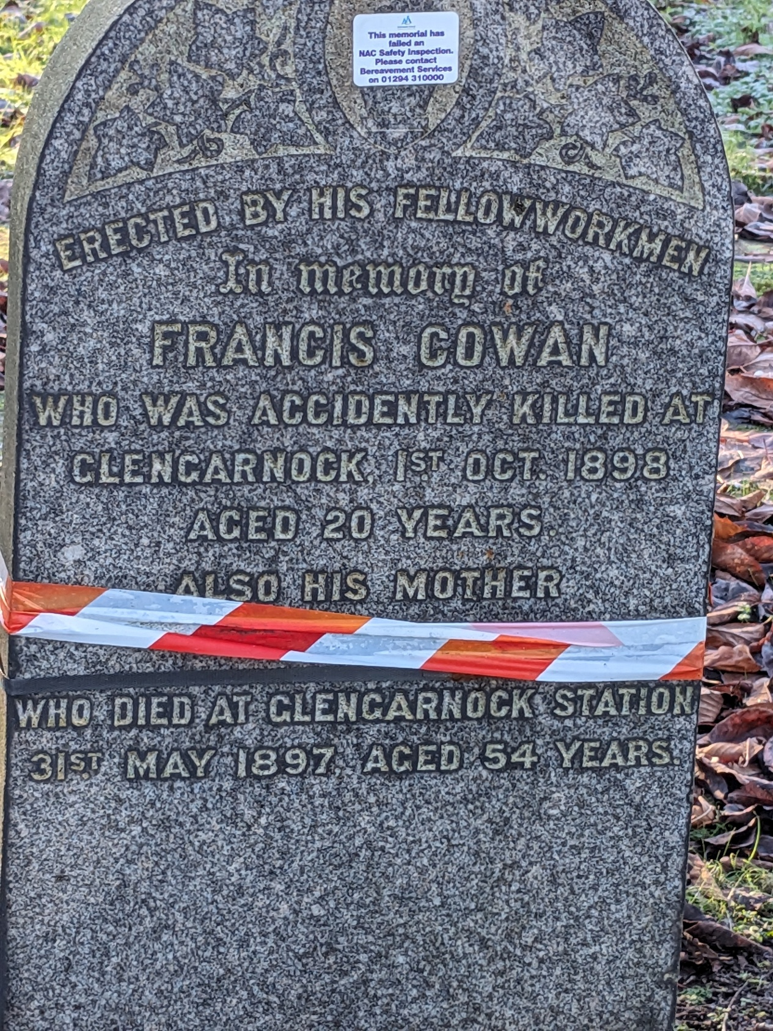
Figure 5. Appendix C.
Headstone with “Failed Safety Test” sticker
From the author’s photographic archive

Appendix C (Continued)

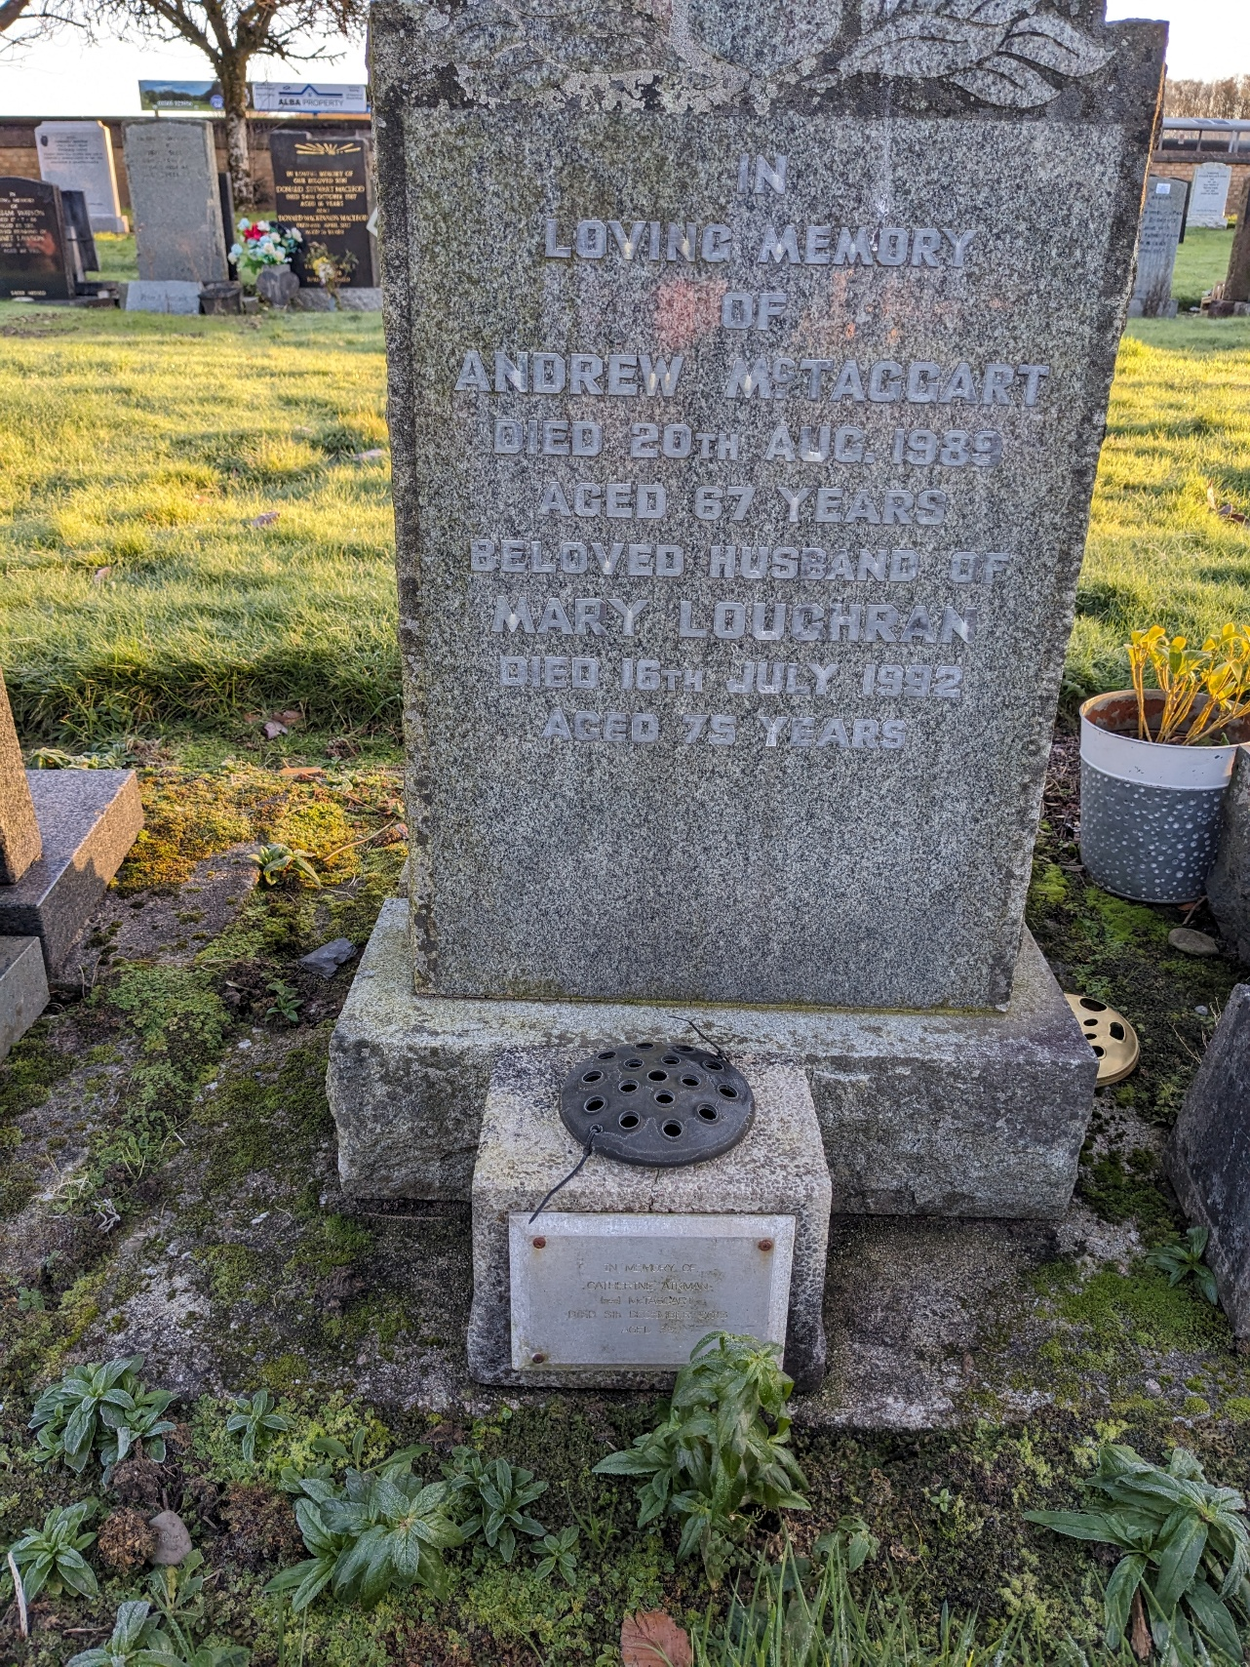

Figure 6. Appendix C.
Headstone with Plaque
From the author’s photographic archive

Appendix C Continued

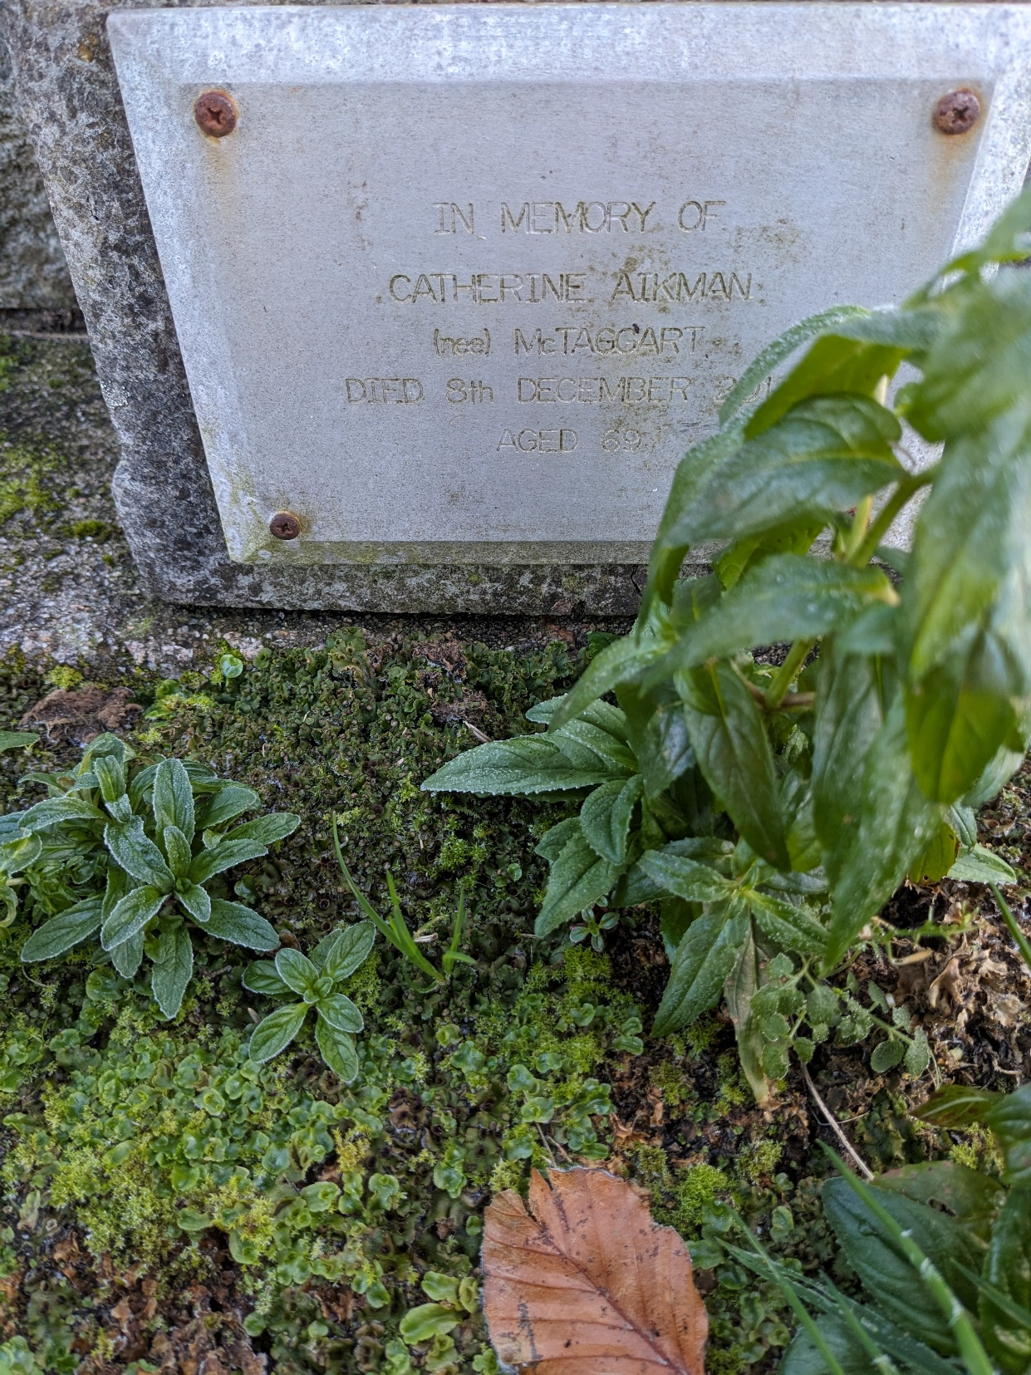
Figure 7. Appendix C.
Plaque.
From the author’s photographic archive

